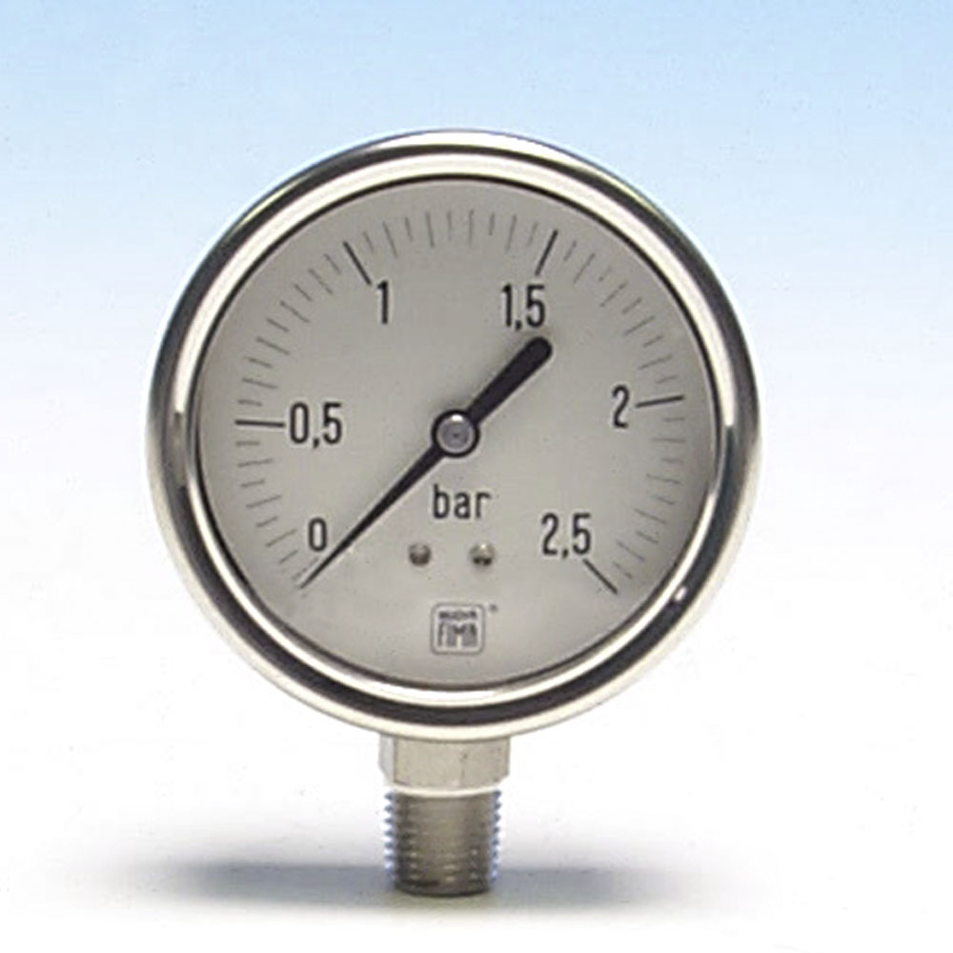
P2500 Series Specifications:

Size: 63mm diameter
Case: 304 Stainless Steel
Internals: 316 Stainless Steel
Filling Liquid: Glycerin
Units: bar or kPa (stocked)
Thread: NPT standard (BSP & BSPT available)
Accuracy: 1.6% of full scale
Nuova Fima Model: 01.18 DS 63

P2500 details

The P2500 Series gauge is the smaller version of our P4000 Series gauge. The sealed case and liquid filling makes it suitable for the harshest of conditions. The addition of the liquid filling extends the life of the gauge by reducing internal vibration as well as reducing the likelihood of penetration of water and/or dirt. The gauge is standard with bar, but kPa and PSI/kPa are available on special order, as are different threads. Panel mounting is available with either a U-clamp or a front flange.

P2500 applications
01.18 DS 63 | Bottom Entry | Rear Entry
Range (bar) | Part # | Part #
0-1 | P2510 | P2560
0-1.6 | P2511 | P2561
0-2.5 | P2512 | P2562
0-4 | P2513 | P2563
0-6 | P2514 | P2564
0-10 | P2515 | P2565
0-16 | P2516 | P2566
0-25 | P2517 | P2567
0-40 | P2518 | P2568
0-60 | P2519 | P2569
0-100 | P2520 | P2570
0-160 | P2521 | P2571
0-250 | P2522 | P2572
0-300 | P2523 | P2573
0-400 | P2524 | P2574
0-600 | P2525 | P2575
0-1000 | P2526 | P2576

The P2500 Series is the ideal gauge for the chemical and petro-chemical industries, and any other industry where you need a long-life, small gauge. By adding a sanitary seal to this gauge it becomes suitable for the food processing industries.

Further information
Further information on this gauge can be found at www.cps.co.nz. At this site you can buy the gauge directly, download data sheets, as well as check out the rest of the gauges available from CPS (NZ)) Ltd, including our Digital Pressure Gauges.

.

OPTIONS: A full range of diaphragm seals are available from CPS (NZ) Ltd including Tri-clover, RJT and more. Also available are U-clamps, wall mount flanges, safety glass and CPS Labs IANZ calibration certificate.

